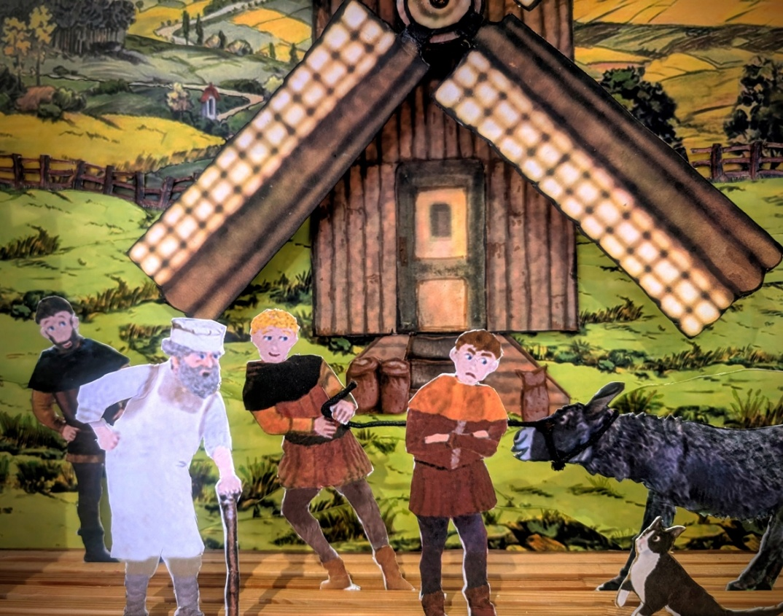

Pollock’s Toy Museum Trust presents
Puss in Boots
The cat that looked at a King and won his master a princess. A toy theatre show with refreshments in a lovely
Georgian house in Bloomsbury
Original production devised and performed
by Sarah Peasgood

Sunday 23 November 2025
The Music Room,
49 Great Ormond Street, WC1N 3HZ
Doors open 2.30. First show 3.00, followed by refreshments, second show 5.00 Tickets price £10 – Children under 12 £5.
Book on Eventbrite

https://www.eventbrite.co.uk/e/puss-in-boots-a-famous-tale-retold-for-paper-theatre-by-sarah-peasgood-tickets-1869500388989

Pollock’s Toy Museum is open during February (6th onwards)
33 Leadenhall Market, EC3V 1LR Tuesdays-Wednesdays 11-4
49 Whitgift Centre, Croydon CR0 1UQ, Saturdays 11-4
See www.pollockstoymuseum.co.uk

