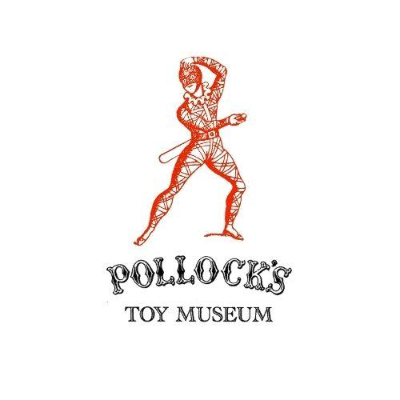

Pollock’s Toy Museum Trust
Registered Charity no.313622
99 Judd Street, London WC1H 9NE

Museum Education Team
Pollock’s Toy Museum Croydon
Unit 49 Whitgift Centre, Croydon, CR9 1SY

School Booking Form

About your School

Name of main school contact
Email address of lead teacher

Name of school or college
School address
School phone number
School type (international, independent, SEN, State, other?)
What are your desired learning objectives for this session?

About your Booking

Year group attending
Number of students
Number of accompanying adults
Type of booking | Education programmes are delivered by Madelaine Wood (holds enhanced DBS certificate)  Pollock’s Toy Museum comes to the School: 45 minutes. Workshop leader visits your school with a range of toys relevant to your studies for pupils to handle and discuss, plus a talk. 1 or 2 workshops in a day (£260). Additional workshops, up to a maximum of 4 in a day, £75 each.  Educational visit to Pollock’s Toy Museum Croydon  (These are temporarily unavailable.)
Preferred date range for visit/trip (please provide a few options in order of preference)
Do any students have specific requirements or accessibility needs?
Any other notes or requirements?

Finances

Head of finance name
Head of finance email
Is the billing address the same as the school address?
If no, please include
Payment method | Please remit to Pollock's Toy Museum, CAF Bank Ltd, account number 00017419, sort code.40-52-40

To be filled out by Pollock’s Education Team:

Notes/variations on booking
Date invoice sent
Date payment received
Method and date of payment

